**COMPUTATIONAL NORM GUIDED POLYMERIZATION FOR ENHANCED CORROSION STABILIZATION**

**TABLE OF CONTENTS**

**1. SOFTWARE DEVELOPMENT LIFE CYCLE**

**2. PLATFORM KNOWLEDGE**

**3. DOMAIN KNOWLEDGE**

**4. ABOUT PROJECT**

4.1 ABSTRACT

4.2 SCOPE OF THE PROJECT

4.3 EXISTING SYSTEM

4.3.1 DISADVANTAGES

4.4 PROPOSED SYSTEM

4.4.1 ADVANTAGES

**5. BOTTOM LINE AND FUTURE ENHANCEMENT**

**6. SOFTWARE AND HARDWARE REQUIREMENTS**

**1. SDLC (Software Development Life Cycle)**

The Software Development Life Cycle is a systematic process for building software that ensures the quality and correctness of the software built. SDLC process aims to produce high-quality software which meets customer expectations. The software development should be completed within the pre-defined time frame and cost.

**SDLC Phases**

The entire SDLC process is divided into the following stages

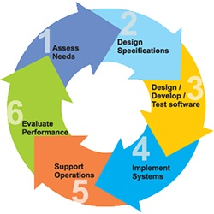

* Phase 1: Requirement gathering and analysis
* Phase 2:Fesability Study
* Phase 3: Design
* Phase 4: Coding
* Phase 5: Testing
* Phase 6: Installation/Deployment
* Phase 7: Maintenance

**2. PLATFORM KNOWLEDGE**

**Introduction to Java**

Java programming language was originally developed by Sun Microsystems which was initiated by James Gosling and released in 1995 as a core component of Sun Microsystems' Java platform. Initially, the language was called “Oak” but it was renamed as “Java” in 1995. The primary motivation of this language was the need for a platform-independent language. Finally, Java is for Internet Programming where C was to System Programming.

**Java architecture**

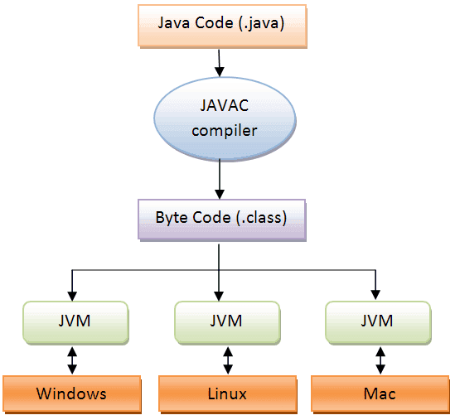Java is a high-level Object-oriented programming language. A program written in high level language cannot be run on any machine directly. First, it needs to be translated into that particular machine language. The javac compiler does this thing, it takes java program (.java file containing source code) and translates it into machine code (referred as byte code or .class file). Java Virtual Machine (JVM) is a virtual machine that resides in the real machine (your computer) and the machine language for JVM is byte code. JVM executes the byte code generated by compiler and produce output. JVM is the one that makes java platform independent

**3. DOMAIN KNOWLEDGE**

**MACHINE LEARNING**

**OVERVIEW**

Machine learning is an application of Artificial Intelligence (AI) that provides systems the ability to automatically learn and improve experience without being explicitly programmed. Machine learning focuses on the development of computer programs that can access data and use it learn for themselves. The primary aim is to allow the computer to learn automatically without human intervention or assistance and adjust actions accordingly.

The test for a machine learning model is a validation error on new data not a theoretical test that proves a null hypothesis. Because this often uses an iterative approach to learn from data, the learning can be easily automated.

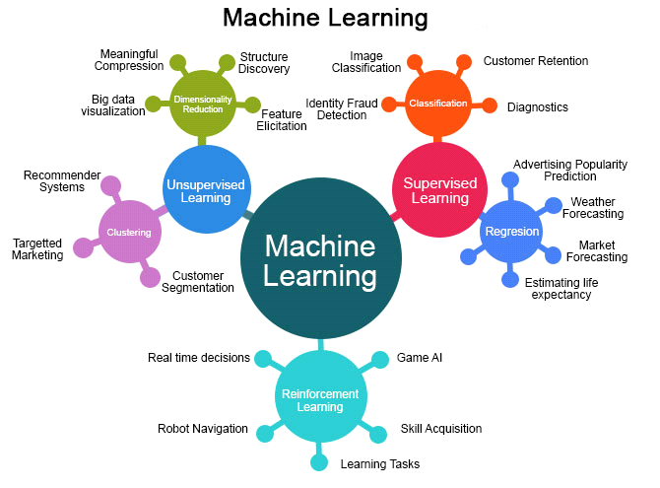

**MACHINE LEARNING METHODS**

Some of the methods of Machine Learning algorithm are categorized as

**SUPERVISED LEARNING**

A Supervised learning algorithm learns from labeled training data, helps you to predict outcomes for unforeseen data. It is highly accurate and trustworthy method.

**UNSUPERVISED LEARNING**

Unsupervised learning algorithm is the type of self - organized with the help of previously unknown patterns in dataset without pre-existing labels.

**SEMI-SUPERVISED LEARNING**

Semi-supervised learning is the combination of both supervised and unsupervised which means labeled and unlabeled data.

**REINFORCEMENT MACHINE LEARNING**

Reinforcement machine learning is an area of machine learning concerned with how software agents ought to take actions in an environment so as to maximize some notion of cumulative reward.

**APPLICATIONS OF MACHINE LEARNING**

* + Video Surveillance
  + Social Media Services
  + Email Spam and Malware Filtering
  + Financial Services
  + Health Care
  + Retail
  + Transportation

**ADVANTAGES**

* + Computational property is cheaper and more powerful.
  + Affordable data storage.
  + It can analysis complex data quickly and automatically.
  + It produces more accurate results.

**COMPUTATIONAL NORM GUIDED POLYMERIZATION FOR ENHANCED CORROSION STABILIZATION**

**4. ABOUT THE PROJECT**

**4.1 Abstract**

The historical incumbency of polymer-based coatings as stalwart guardians against corrosion is underscored by their enduring physical robustness and chemical inertness. However, the gradual propensity of traditional polymer coatings to undergo deleterious deterioration over temporal epochs precipitates an inexorable attenuation of their once-potent efficacy. In response to this, the present scholarly inquiry embarks upon an odyssey into the integration of bio-polymers, ethically sourced from sustainable reservoirs, to fortify the anti-corrosive fortifications of their conventional polymer counterparts. A paradigmatic shift in corrosion prophylaxis unfolds through the pioneering introduction of self-healing modalities. The proposed modus operandi endeavors to autonomously rectify infinitesimal aberrations in the coating by instilling elements imbued with innate reparative properties. This innovative orchestration not only bestows upon the coating an extended lifespan but concurrently alleviates the exigencies of maintenance. This project focuses on corrosion in industry based applications such as oil and gas industries, marine where corrosion is common. This can be rectified using anti corrosion polymers. Using Entry Norm Optimization algorithm implemented, optimizes the selection of materials by considering entry norms related to factors like cost, availability, and environmental impact. It streamlines the process of choosing the most suitable anti-corrosion materials for specific applications The multifaceted attributes of the synthesized materials, encompassing mechanical resilience, chemical composition, and self-healing prowess, undergo scrupulous dissection. within the purview of the investigatory methodology. Furthermore, the crucible of scrutiny extends to the evaluation of corrosion resistance, a crucible where accelerated testing methodologies and exposure to exacting environmental conditions.

**4.2 Scope of the Project**

In the multifaceted landscape of diverse industries, the ubiquitous menace of corrosion emerges as a formidable adversary, imperiling the endurance and structural soundness of metallic components. Within this abstract, a sophisticated and avant-garde approach is expounded upon, emanating from the vanguard of materials science methodologies, in the relentless pursuit of corrosion mitigation. The focal point of this intellectual expedition resides in the synergistic fusion of bio-polymers, embellished with self-mending propensities, and their conventional polymer counterparts. A project centered on bio-polymers and polymers with self-healing properties for anti-corrosion purposes has a wide scope that includes several parts of research, development, and real-world applications. Create mixtures of polymer and biopolymer that have the best possible anti-corrosive and self-healing qualities. Describe the mechanical, chemical, and physical characteristics of the materials that were synthesized .Examine the effects of bio-polymers on overall performance and their compatibility with conventional polymers. Investigate and put into practice self-healing systems, such as responsive polymers that can self-heal damage or microcapsule s that contain healing substances. Examine self-healing mechanisms' kinetics and effectiveness in various environmental settings. Test the developed materials for accelerated corrosion to determine how effective they are Examine how resistant the materials are to corrosive conditions, such as exposure to humidity, salt spray, and harsh chemicals. To get the optimal balance between mechanical qualities, self-healing capabilities, and anti-corrosive performance, optimize the composition and ratios of polymer-bio-polymer blends Look into sustainable and eco-friendly sources for bio-polymers. Create application methods for coatings that prevent corrosion on various substrates and surfaces. Examine if current coating application techniques in sectors including manufacturing, transportation, and infrastructure are compatible. Examine how the produced coatings would affect the environment, taking into account things like resource sustainability, biodegradability, and recycling potential.

**4.3 Existing System**

Polymer coatings are applied to metal surfaces to serve as a barrier against corrosive environments. Certain qualities, like adhesion, flexibility, and chemical resistance, can be customized for these coatings adding nanomaterials, such as nanoparticles or nanotubes, to polymer matrices in order to improve the coatings' mechanical and barrier qualities. Durability and corrosion resistance may both be enhanced by this Since epoxy resins have good adhesion, chemical resistance, and durability, they are frequently employed in anti-corrosion coatings. Epoxy formulation improvements and modifications are still being investigated.

**4.3.1 Disadvantages**

* When exposed to exceptionally aggressive corrosive substances or extremely severe environmental conditions, certain anti-corrosion polymers may not function at their best.
* Anti-corrosion coatings may deteriorate or need maintenance over time, requiring recoating or repair work to provide continuous protection.
* Certain anti-corrosion polymers may be produced using procedures and chemicals that have an adverse effect on the environment, increasing resource consumption and pollution.
* The processing and manufacture of polymers may present difficulties, such as melt viscosity, heat stability, and equipment compatibility problems.
* In the presence of exceptionally aggressive corrosive substances or under extremely severe environmental conditions, certain anti-corrosion polymers may experience reduced effectiveness.

**4. Proposed System**

Cutting-edge corrosion protection strategies rely on intricate polymer matrix nanocomposites with biologically inspired self-healing mechanisms. These materials' nanoscale reinforcements enhance their overall mechanical and barrier properties by residing in the polymer matrix. Often, these reinforcements take the shape of nanotubes or nanoparticles. These sensitive components detect corrosion and set off a healing cascade that aids in the material's integrity being restored This amalgamation of responsive matrices, bio-polymers, nanocomposites in and self-healing processes represents a paradigm change toward corrosion prevention that is both sustainable and cutting edge. This project focuses on corrosion in industry based applications such as oil and gas industries, marine where corrosion is common. This can be rectified using anti corrosion polymers. Using Entry Norm Optimization algorithm implemented, optimizes the selection of materials by considering entry norms related to factors like cost, availability, and environmental impact, these sophisticated anti-corrosion systems not only lessen the effects of corrosion but also support the more general objectives of materials resilience and environmental sustainability.

**4.4.1 Advantages**

* Offers protection against chemical corrosion, making them suitable for industries with chemical exposure.
* Offers a wide range of possibilities for sustainable and self-repairing materials in different industries.
* Increases the lifespan of materials by repairing small cracks and scratches, reducing the need for manual repairs.
* Environment Analysis process can be easily done .
* Polymer or Biopolymer Material selected by based on Environment Analysis.

.

**5. BOTTOM LINE AND FUTURE ENHANCEMENT**

Continued progress in nanotechnology may lead to the development of more advanced nanocomposite materials with enhanced corrosion resistance. Tailoring nano-particles at the atomic and molecular levels could result in materials with superior barrier properties and self-healing capabilities. Exploration of green corrosion inhibitors and eco-friendly coatings that are effective against corrosion while minimizing environmental impact. This may involve the use of bio-based compounds and natural extracts with corrosion-inhibiting properties Integration of multifunctional coatings that not only prevent corrosion but also offer additional functionalities, such as antifouling properties, UV resistance, and antibacterial capabilities Exploration of green corrosion inhibitors and eco-friendly coatings that are effective against corrosion while minimizing environmental impact. This may involve the use of bio-based compounds and natural extracts with corrosion-inhibiting properties.

**6. HARDWARE AND SOFTWARE REQUIREMENTS**

**Hardware requirements:**

* Processor : Intel (R) Pentium (R)
* Speed : 1.6 GHz and Above
* RAM : 4 GB and Above
* Hard Disk : 120 GB
* Monitor : 15’’ LED SVGA
* Input Devices : Keyboard, Mouse

**Software requirements:**

* Operating system : Windows 8 / 8.1 / 10
* Coding Language : JAVA / J2EE
* Java Version : jdk 8
* IDE : Eclipse Oxygen
* Database : MySQL v5.1
* Database Tool : HeidiSQL v11.0
* Application Server : Apache Tomcat 8.X / 9.X